**Jibestream Representative Projects**

**Project name:** Kaleida Health - <https://www.kaleidahealth.org/>

**Location:** Buffalo, NY

**Contract delivery method**: Direct contract from Kaleida Health to Jibestream

**Description:** Kaleida Health is the largest healthcare provider and private employer in Western New York, serving the area’s eight counties with state-of-the-art technology and comprehensive healthcare services.

Known for their commitment to innovation and technology, Kaleida Health was awarded the “Most Wired Innovator award” in 2017 for their Find Your Way app which leverages Jibestream’s indoor mapping platform to bring indoor maps, walking directions and wayfinding to their facility helping patients and visitors more easily navigate to appointments, treatment rooms, and other points of interest.

Kaleida Health’s journey to create a situationally aware and patient-centered environment began in response to the increasing pressure to enhance patient and visitor satisfaction. The initial addition of wayfinding to the Kaleida Health app was coordinated to launch simultaneously with the grand opening of the new Oishei Children’s Outpatient Center to alleviate concerns about navigating the new facility. The center opened its doors in January 2017 and currently houses the first outpatient clinics to relocate from Women & Children’s Hospital of Buffalo.

Followed by the Oishei Children’s Outpatient Center, Kaleida expanded their Jibestream wayfinding deployment with Conventus, Buffalo General Medical Center, Gates Vascular Institute (GVI), Millard Fillmore Suburban Hospital.

Kaleida Health’s network consists of six hospitals, with over 5.6 million square feet in total deployed using Jibestream’s mapping platform.

Kaleida Health’s team were looking to achieve three main objectives:

1. Increase Patient Satisfaction using wayfinding as a key foundational layer
   * provide patients and families with a stress-free way to get around
   * provide the best possible experience for patients and visitors
2. Connect, communicate, and collaborate more effectively
   * give patients the best tools to make their visit as smooth as possible
   * create an experience that is dynamic, accessible and engaging
3. Deploy a mapping platform that was scalable and flexible and could extend beyond basic wayfinding
   * utilize a technology that offered seamless integration and could be embedded into their existing app
   * invest in a future proof solution that could address supplementary use cases including support for an internal staff app

[INTERNAL: these are University Health’s stated objectives:]

* *Create a positive patient experience*
* *Improve patient satisfaction*
* *Reduce costs from missed and late appointments*
* *Maximize employee productivity by reducing the time visitors ask hospital staff for directions*

The app was built by an in-house Kaleida Health developer (iOS & Android via Cordova) using Jibestream’s mapping platform along with a third-party Indoor Positioning System provider leveraging BLE Beacons for location services.

**Screen capture of several aspects of completed wayfinding projects – maps, navigation, dashboard, welcome page, search functions, parking, kiosks, content manager, reports, etc.**

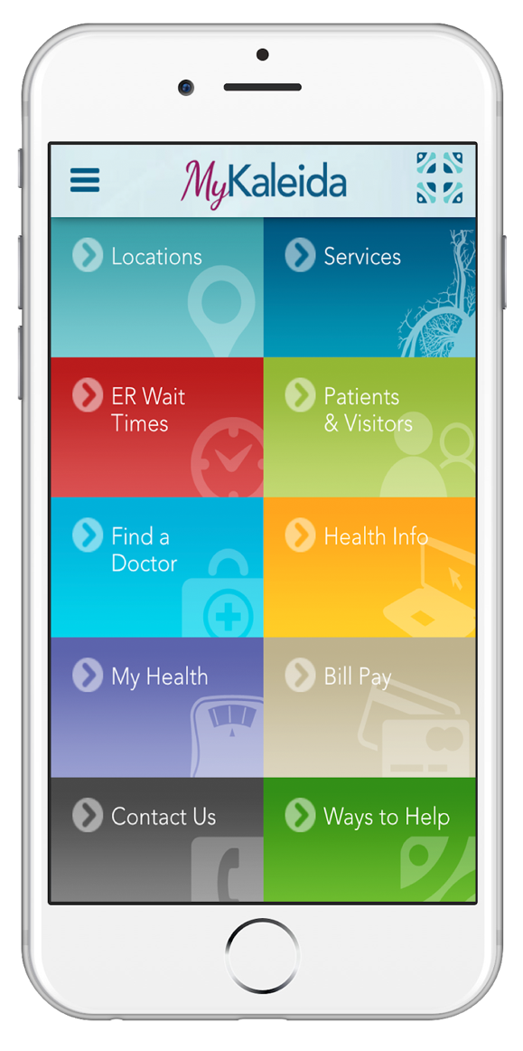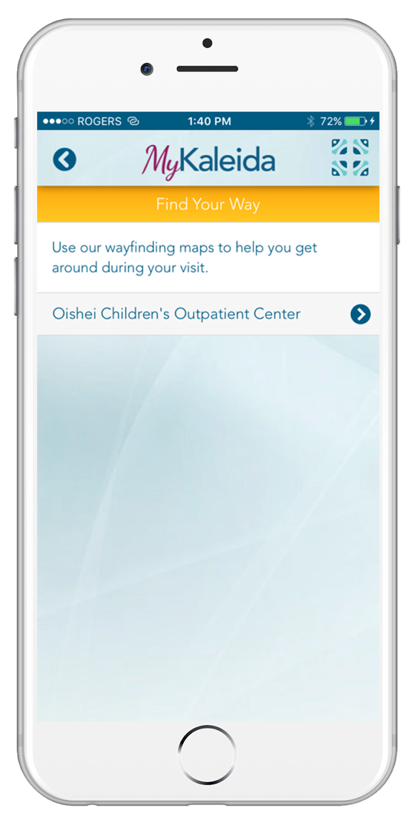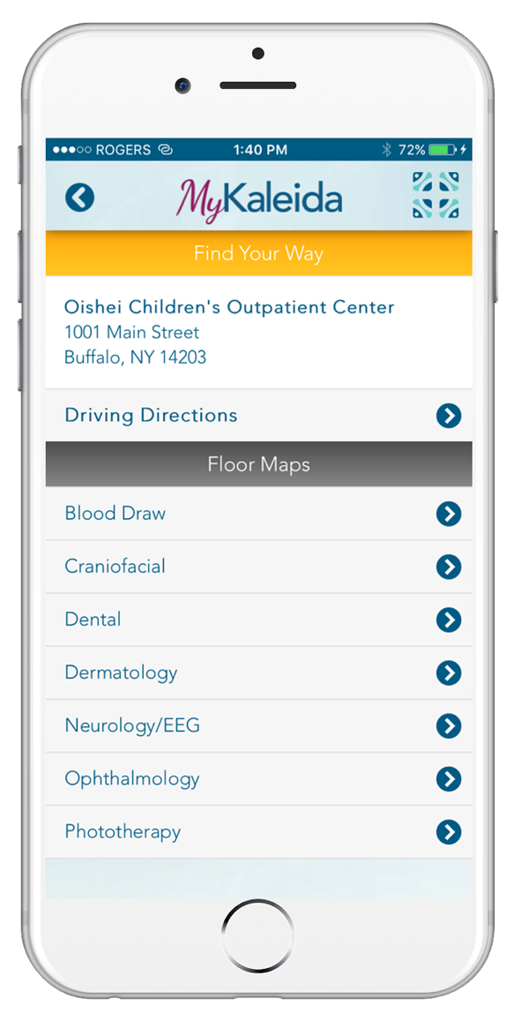

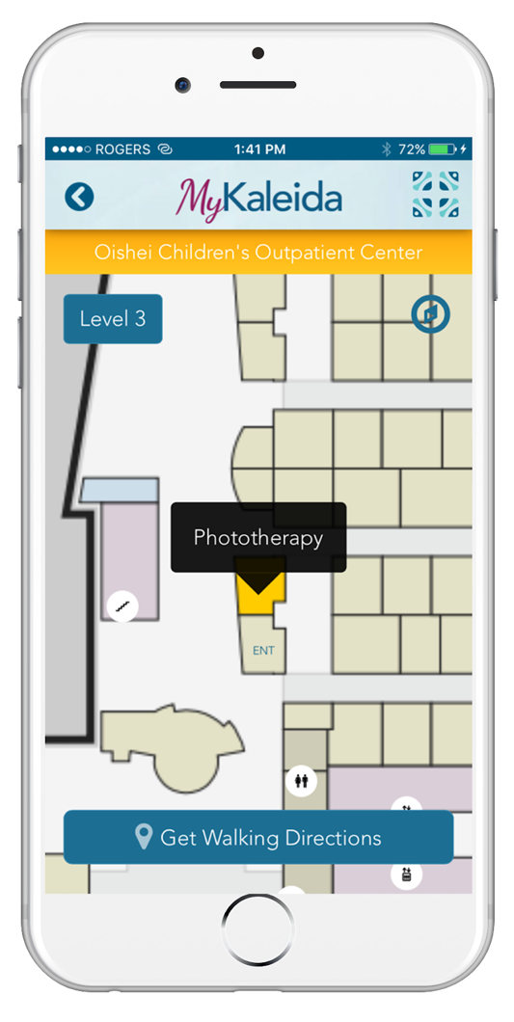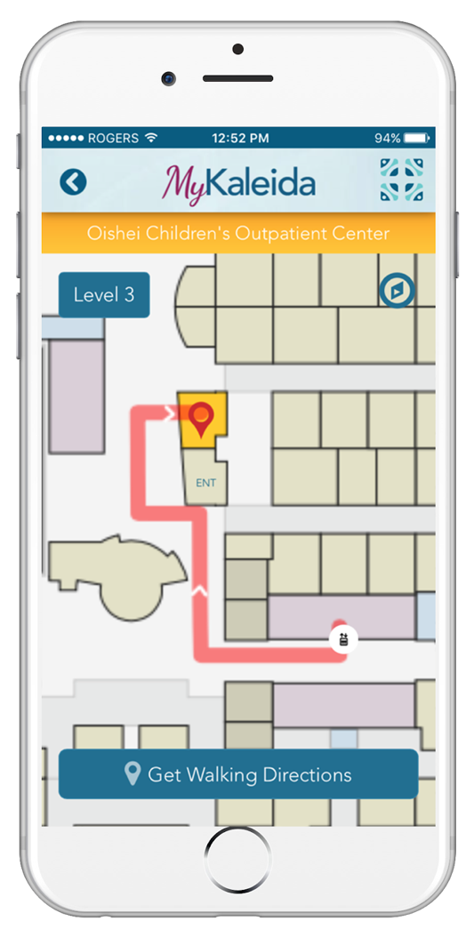

Blue-dot wayfinding at Kaleida Health: <https://youtu.be/cDA79oVZLdE>

**Description of professional services that Respondent provided for the project:**

*Map Digitization:*

Starting from the source files (.CAD) of the facility maps, the Jibestream mapping and design team converted the map files into .svg format with an appropriate level of detail and information for patients and visitors. This work involved removing certain layers that were not relevant (i.e. electrical closets) while adding aesthetic and contextual elements (i.e. pond, parking lots). To make the maps interactive and useful to end users, the mapping team created the navigable pathways and verified the uploaded points of interests/destinations.

*Developer Implementation Support:* Kaleida Health had an existing app developed in-house that the maps were being added into. Jibestream developers supported the Kaleida Health developer using the SDKs, APIs to implement ‘blue dot’ wayfinding functionality across all 5 of their hospitals with a 6th facility going into production summer of 2019.

**Final project size in square footage**: 5.6 Million square feet

**Type of project (new, redesign, or enhancement): Mixed combination of new and enhancements for the various 7 campuses deployed**

**Actual start and finish dates for planning, execution and implementation:**

Start date: October 7, 2016

End date: December 12, 2017

**Name of Owner’s point of contact:** Chris Wiegand, Jibestream CEO

**Name of Respondent’s point of contact:** Cletis Earle, Kaleida Health CIO

**Describe how the project is similar and why the services provided are most relevant to the project described in this solicitation.**

The project at Kaledia Health is similar to the project in this solicitation as the following are required in both projects:

* one any only mobile app for patients, visitors and family members
* complex buildings and campuses spanning many floors, parking lots, etc.
* location aware with real-time indoor positioning
* align to hospital brand guidelines
* accommodate real time updates and changes
* provide accurate guidance and wayfinding to various destinations/departments

**Clearly identify the members of the proposed Project Team who worked on the listed projects, and describe their roles in those projects.**

*Dana Marciniak*, Program Manager

* Consulting, Subject Matter Expert on Maps and Implementation (Expert on complexities of map and project solutioning)

*Stephanie Guarini*, Technical Design Lead

* Professional Services, Map Designer (convert CAD drawings, map design, creation, solutioning)

*Amanda Ing*, Implementation Specialist:

* Professional Services, Map implementation/configuration (adding destinations, amenities, walking paths, map QA)

**References:**

Brian DiCicco - IT - Web Technology Team  
Email: [bdecicco@kaleidahealth.org](mailto:bdecicco@kaleidahealth.org)    
Phone: (716) 859-8181

**Project name:** Lee Health Coconut Point - <http://www.leehealth.org/coconut-point/index.asp>

**Location:** 23450 Via Coconut Point, Estero, FL 33928

**Contract delivery method**: Direct contract from Lee Health to Jibestream

**Description:** Lee Health, formerly Lee Health Memorial, is the largest hospital operator in Southwest Florida. The not-for-profit is comprised of a network of six hospitals and more than 100 outpatient clinics.

Serving more than 100,000 Southwest Florida residents, Coconut Point is the newest addition to the Lee Health family. This state-of-the-art healthcare campus features a cutting-edge outpatient facility in addition to a freestanding emergency department, the first of its kind in Lee County. With major expansion plans, Coconut Point will scale over the next three years from a 10 bed, 163,000 square foot facility to a 114 bed, 500,000 square foot health and wellness destination.

Entering a new and jurisdiction in a competitive landscape, Lee Health needed a strategy that would enable them to differentiate themselves and keep pace as their infrastructure grew.

The Lee Health team recognized the potential value of a well developed mobile app and wanted to further invest in it to help create an easy and stress-free experience for patients and facility guests. Coming to a hospital is already an uncomfortable experience. Lee Health wanted to allow patients to walk into a facility and be able to focus on their health instead of worrying about getting lost.

Lee Health’s team set out to achieve three main objectives:

1. To differentiate themselves in today's competitive healthcare market by leveraging technology
2. To provide real-time indoor wayfinding to patients and other hospital visitors
3. To lay the foundation for building a Real-Time Health System (RTHS) across their hospital network

The app was built by an in-house Lee Health developer (iOS & Android) using Jibestream’s mapping platform along with a 3rd party Indoor Positioning System provider leveraging BLE Beacons for location services.

**Screen capture of several aspects of completed wayfinding projects – maps, navigation, dashboard, welcome page, search functions, parking, kiosks, content manager, reports, etc.**

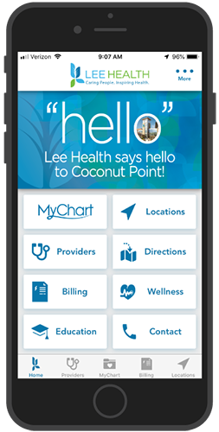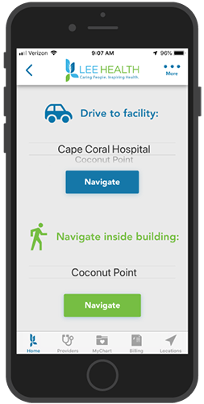

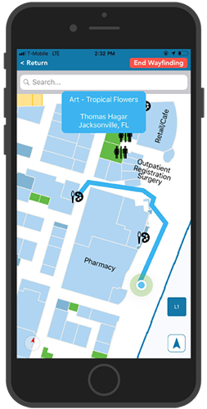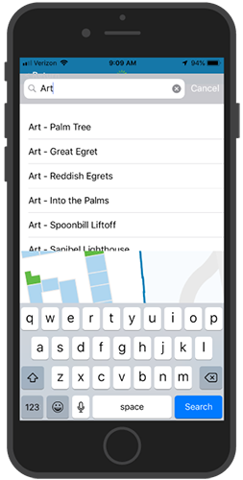

**Description of professional services that Respondent provided for the project:**

Jibestream professional services on the project were focused on two major areas, map digitization and developer implementation support.

*Map Digitization:*

Starting from the source files (.CAD) of the facility maps, the Jibestream mapping and design team converted the map files into .svg format with an appropriate level of detail and information for patients and visitors. This work involved removing certain layers from the architectural drawing that were not relevant (i.e. electrical closets) while adding aesthetic and contextual elements (i.e. pond, trees, art installations). To make the maps interactive and useful to end users, the mapping team created the navigable pathways and verified the uploaded points of interests/destinations. Other professional services included project management and consultations with Jibestream’s subject matter experts.

*Developer Implementation Support:*

Lee Health had an existing app developed in-house that the maps were being added into. Jibestream developers supported the Lee Health developer using the SDKs, APIs to implement ‘blue dot’ wayfinding functionality.

**Final project size in square footage:** 500,000 sq. ft.

**Type of project (new, redesign, or enhancement):** New Building

**Actual start and finish dates for planning, execution and implementation**

Start date: July 12, 2018

End date: November 20, 2018

**Name of Owner’s point of contact:** Jonathan Witenko,

**Name of Respondent’s point of contact:** Vinay Iyer

**Describe how the project is similar and why the services provided are most relevant to the project described in this solicitation.**

The project at Lee Health Coconut Point is similar to the project in this solicitation as the following are required in both projects:

* One and only mobile app for patients, visitors and family members
* location aware with real-time indoor positioning
* align to hospital brand guidelines
* accommodate real time updates and changes
* provide accurate guidance and wayfinding to various destinations/departments
* Fully ADA compliant
* Multiple complex routing algorithms

**Clearly identify the members of the proposed Project Team who worked on the listed projects,  and describe their roles in those projects.**

*Dana Marciniak*, Program Manager

* Consulting, Subject Matter Expert on Maps and Implementation (Expert on complexities of map and project solutioning)

*Stephanie Guarini*, Technical Design Lead

* Professional Services, Map Designer (convert CAD drawings, map design, creation, solutioning)

*Amanda Ing*, Implementation Specialist:

* Professional Services, Map implementation/configuration (adding destinations, amenities, walking paths, map QA)

**References:**

Jonathan Witenko  
Sr. Business Systems Analyst – Project Manager

Email: [Jonathan.Witenko@LeeHealth.org](mailto:Jonathan.Witenko@LeeHealth.org)

Phone: 239-343-8012

**Project Name:** Westfield Malls (Global) – [www.westfield.com](http://www.westfield.com)

**Location**: 87 locations in multiple countries, over 3 continents

**Contract Delivery Method**:

Project name, location, contract delivery method, and description:

Name: Westfield Malls

Location: 87 locations in multiple countries, over 3 continents

Delivery method: Web, Kiosks, iOS app, Android app

Description: Westfield is one of world’s largest retail companies that focuses heavily on providing the best user experience with their digital platforms. The guest facing mobile app provides turn-by-turn directions to the various destinations within their malls.

Our location engine is also integrated into Westfield’s other core systems such as tenancy management. Deployment includes one of their key locations – One World Trade Centre, NYC as well as Europe’s largest mall – Westfield London.

Screen capture of several aspects of completed wayfinding projects – maps, navigation, dashboard, welcome page, search functions, parking, kiosks, content manager, reports, etc.

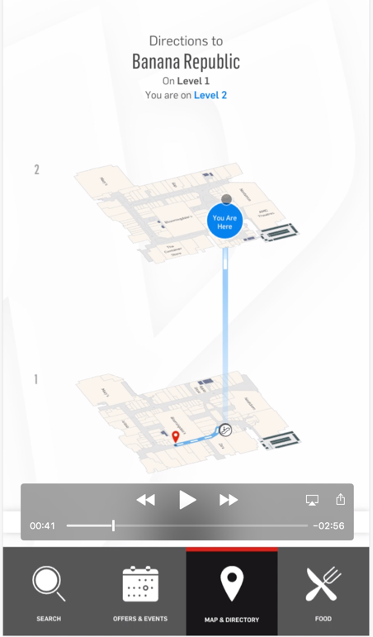Kiosk at Westfield – Century city, Los Angeles, California

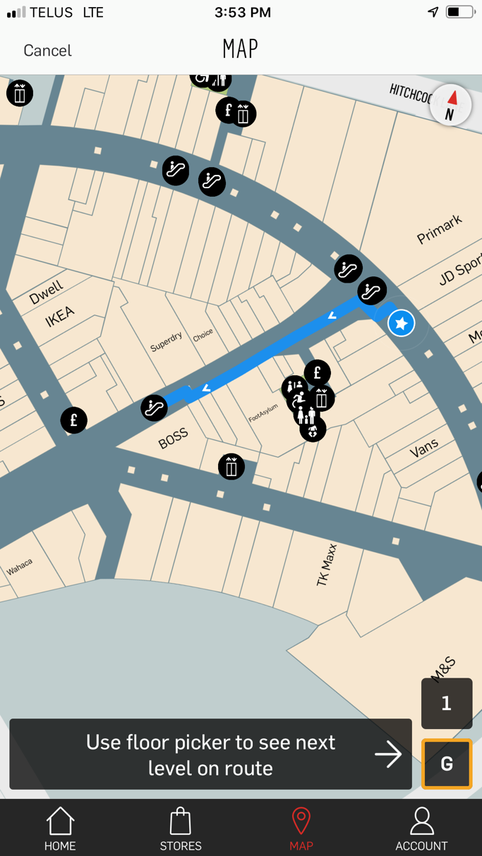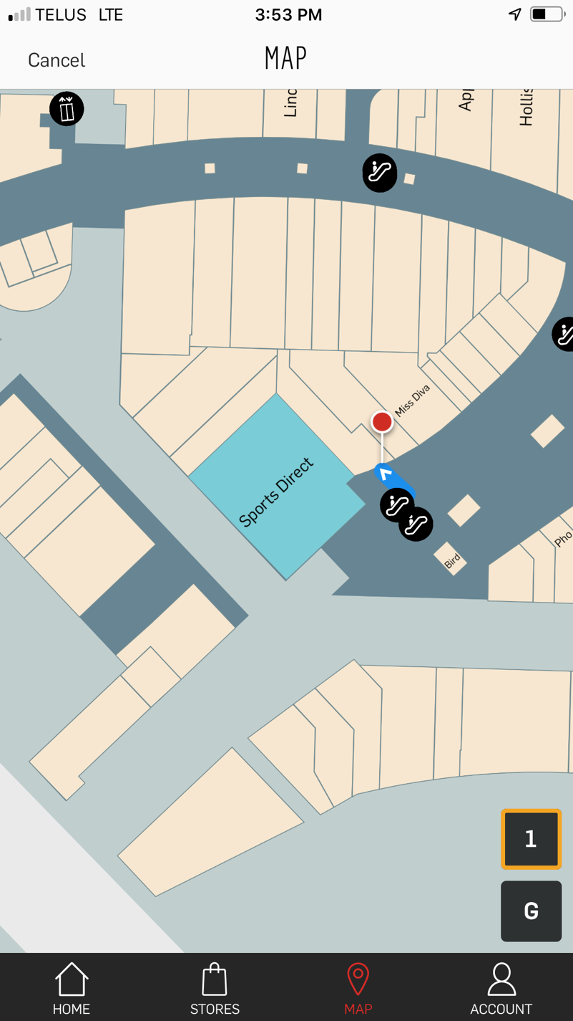

**Description of professional services that Respondent provided for the project**

Map Digitization: After a successful proof of concept with their 3 locations, maps were digitized for the rest of their 86 locations by our map digitization team. CAD files were converted into layer-based, programmatically addressable maps that matched the design and branding guidelines of Westfield’s brand.

Support was provided for BLE beacons and Indoor Positioning integration in order to provide the blue-dot navigation in some of their malls.

**Final project size in square footage**

Individual malls range between 400,000 sq. feet to the largest mall being 2.6 million sq. feet. With 89 malls, the total project size is approximately 50 million sq. feet.

**Type of project (new, redesign, or enhancement): Mixed combination of new and enhancements for the various 7 campuses deployed**

Start date: June 2014

Finish date: August 2015

Owner’s point of contact: Roschelle Lowe, Product Owner

One Market (formerly Westfield)

[rlowe@onemarketnetwork.com](mailto:rlowe@onemarketnetwork.com)

925.658.0429

**Name of Respondent’s point of contact:** Chris Wiegand, CEO

Describe how the project is similar and why the services provided are most relevant to the project described in this solicitation.

The project at Westfield is similar to the project in this solicitation in the following ways:

* One and only mobile app for guests
* Other platforms include digital touchscreen kiosks and website
* Other complex integrations with back of the house platforms
* Buildings and campuses spanning multiple floors, parking lots etc.
* Significant analytics provided including statistics such as dwell times, real time and historical heat maps, etc.
* Location aware with real-time indoor positioning in select high-end malls including Europe’s largest mall in London, England
* Accommodate real-time updates and changes to maps
* Provide accurate guidance and wayfinding to various stores and amenities (ATMs, Restrooms, etc.)
* Fully ADA compliant

**Clearly identify the members of the proposed Project Team who worked on the listed projects, and describe their roles in those projects.**

*Dana Marciniak*, Program Manager

* Consulting, Subject Matter Expert on Maps and Implementation (Expert on complexities of map and project solutioning)

*Stephanie Guarini*, Technical Design Lead

* Professional Services, Map Designer (convert CAD drawings, map design, creation, solutioning)

*Amanda Ing*, Implementation Specialist:

* Professional Services, Map implementation/configuration (adding destinations, amenities, walking paths, map QA)